**My sprint templet**

# User Case Sprint

# My Activities:

1. C:\software\Java\apache-activemq-5.13.2\bin>activemq start
2. http://127.0.0.1:8161/admin/

# Diagram

1. 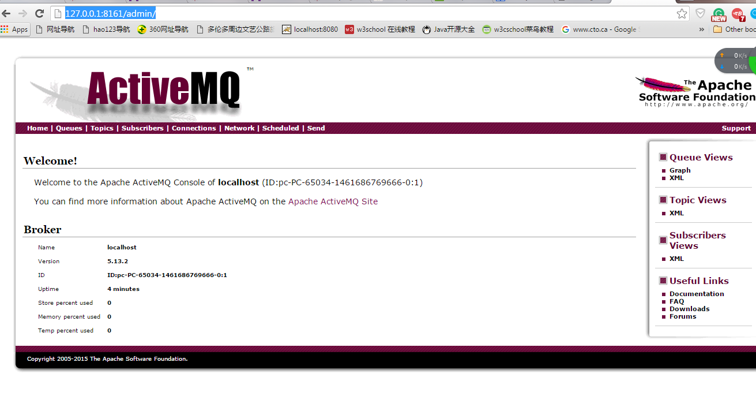

# All excerpt